Updating to iOS7

Please follow the directions below to update your iPad to the new iOS7. This update takes a long time so it must be done at home.

- Tap on “Settings” on the home screen, then “General.”
- Tap on “Software Update”
- Tap on “download” – make sure your iPad is plugged, then let it do it’s thing.

After the download is complete follow the steps below.

- When the download is complete you will see a “Hello” screen. Swipe across to open the screen.

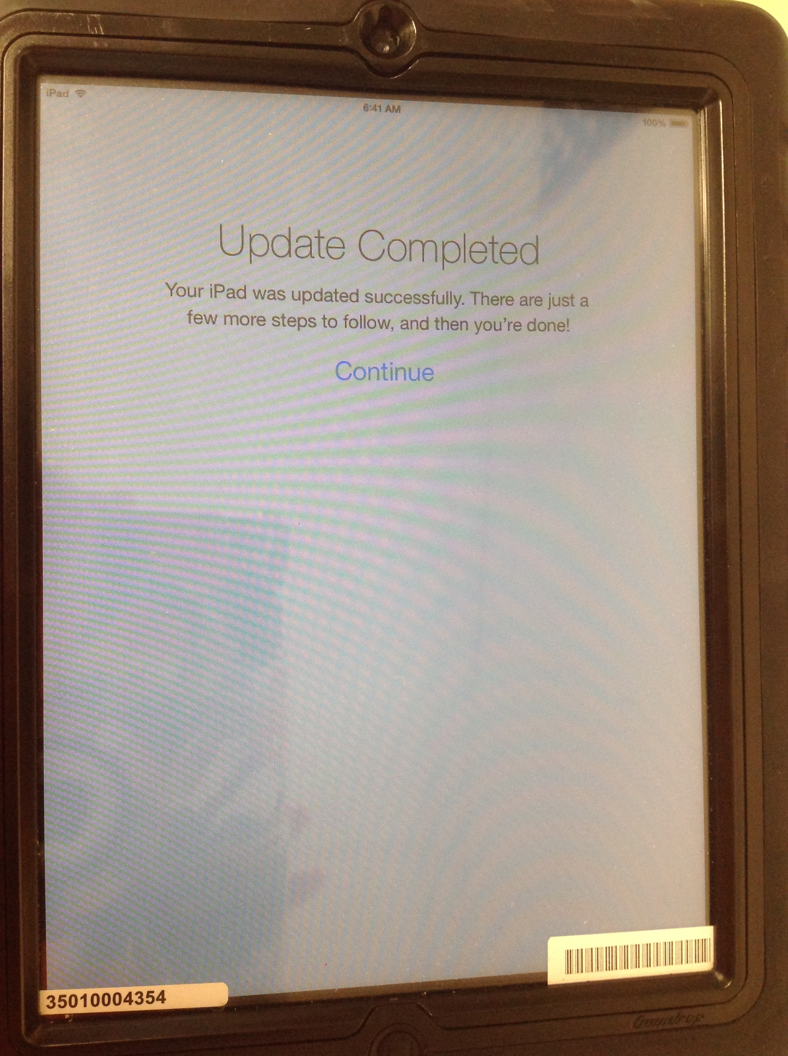
- Tap on “continue”

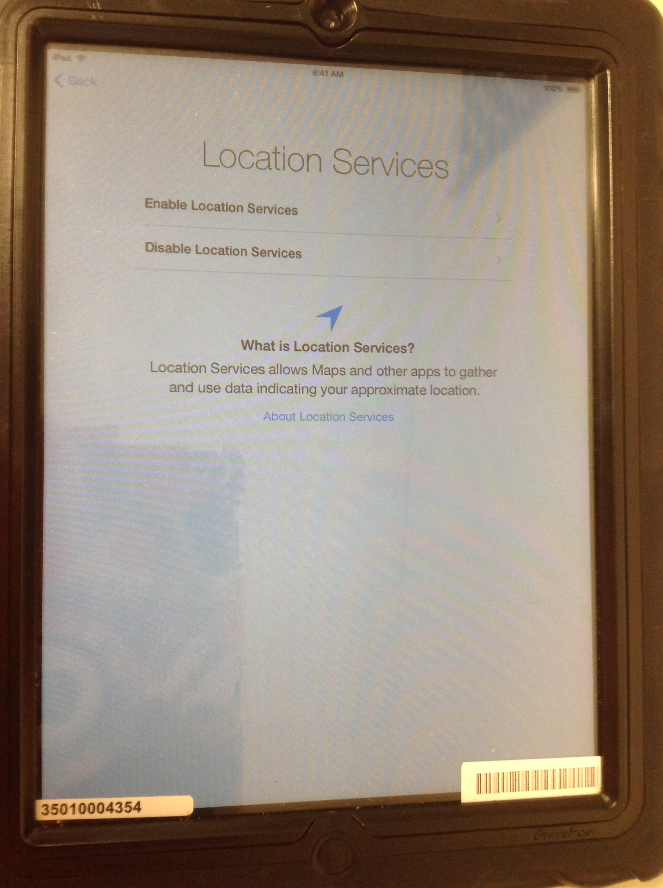

Tap on “Enable Location Sevices”

- The next page is the Apple ID page – you do not have an Apple ID. Tap on “Skip this Step.”

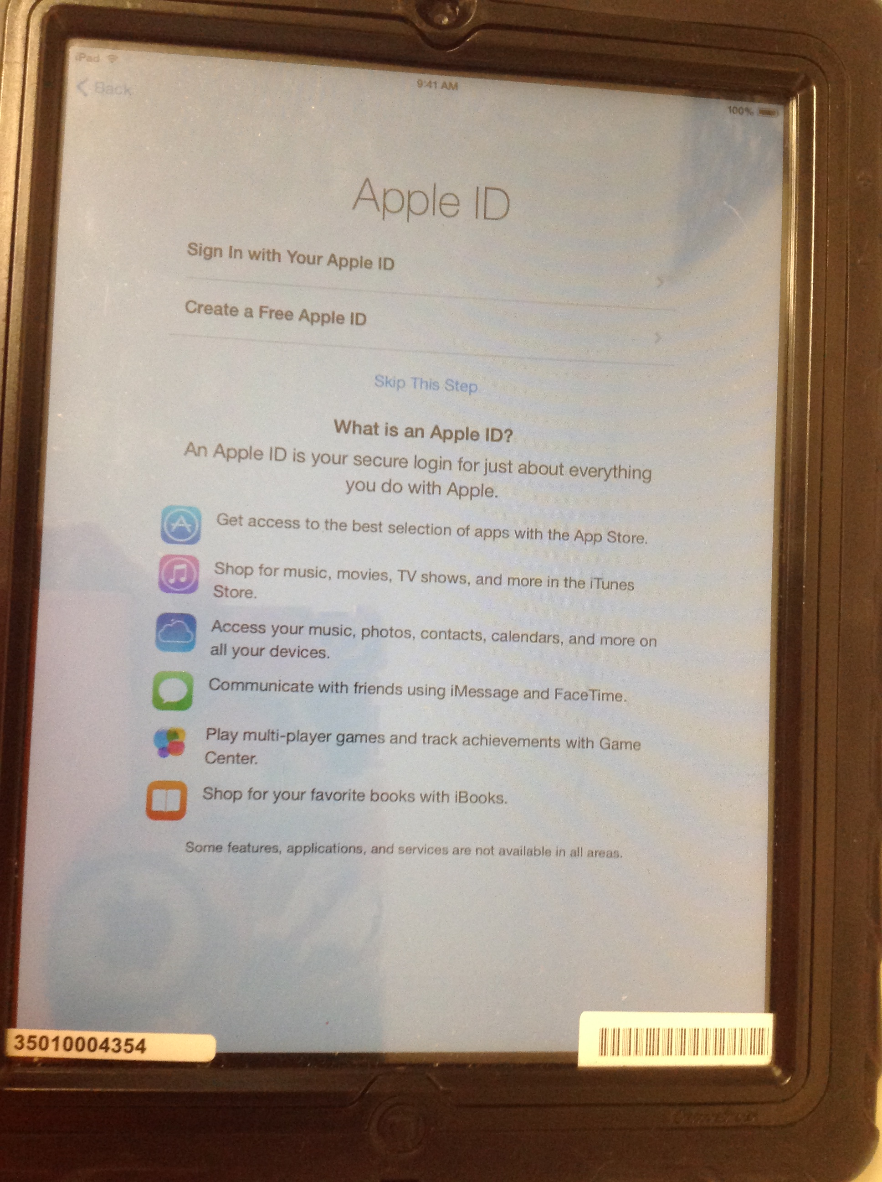

- A box will open up asking you, “Are you sure?” Tap “Skip”

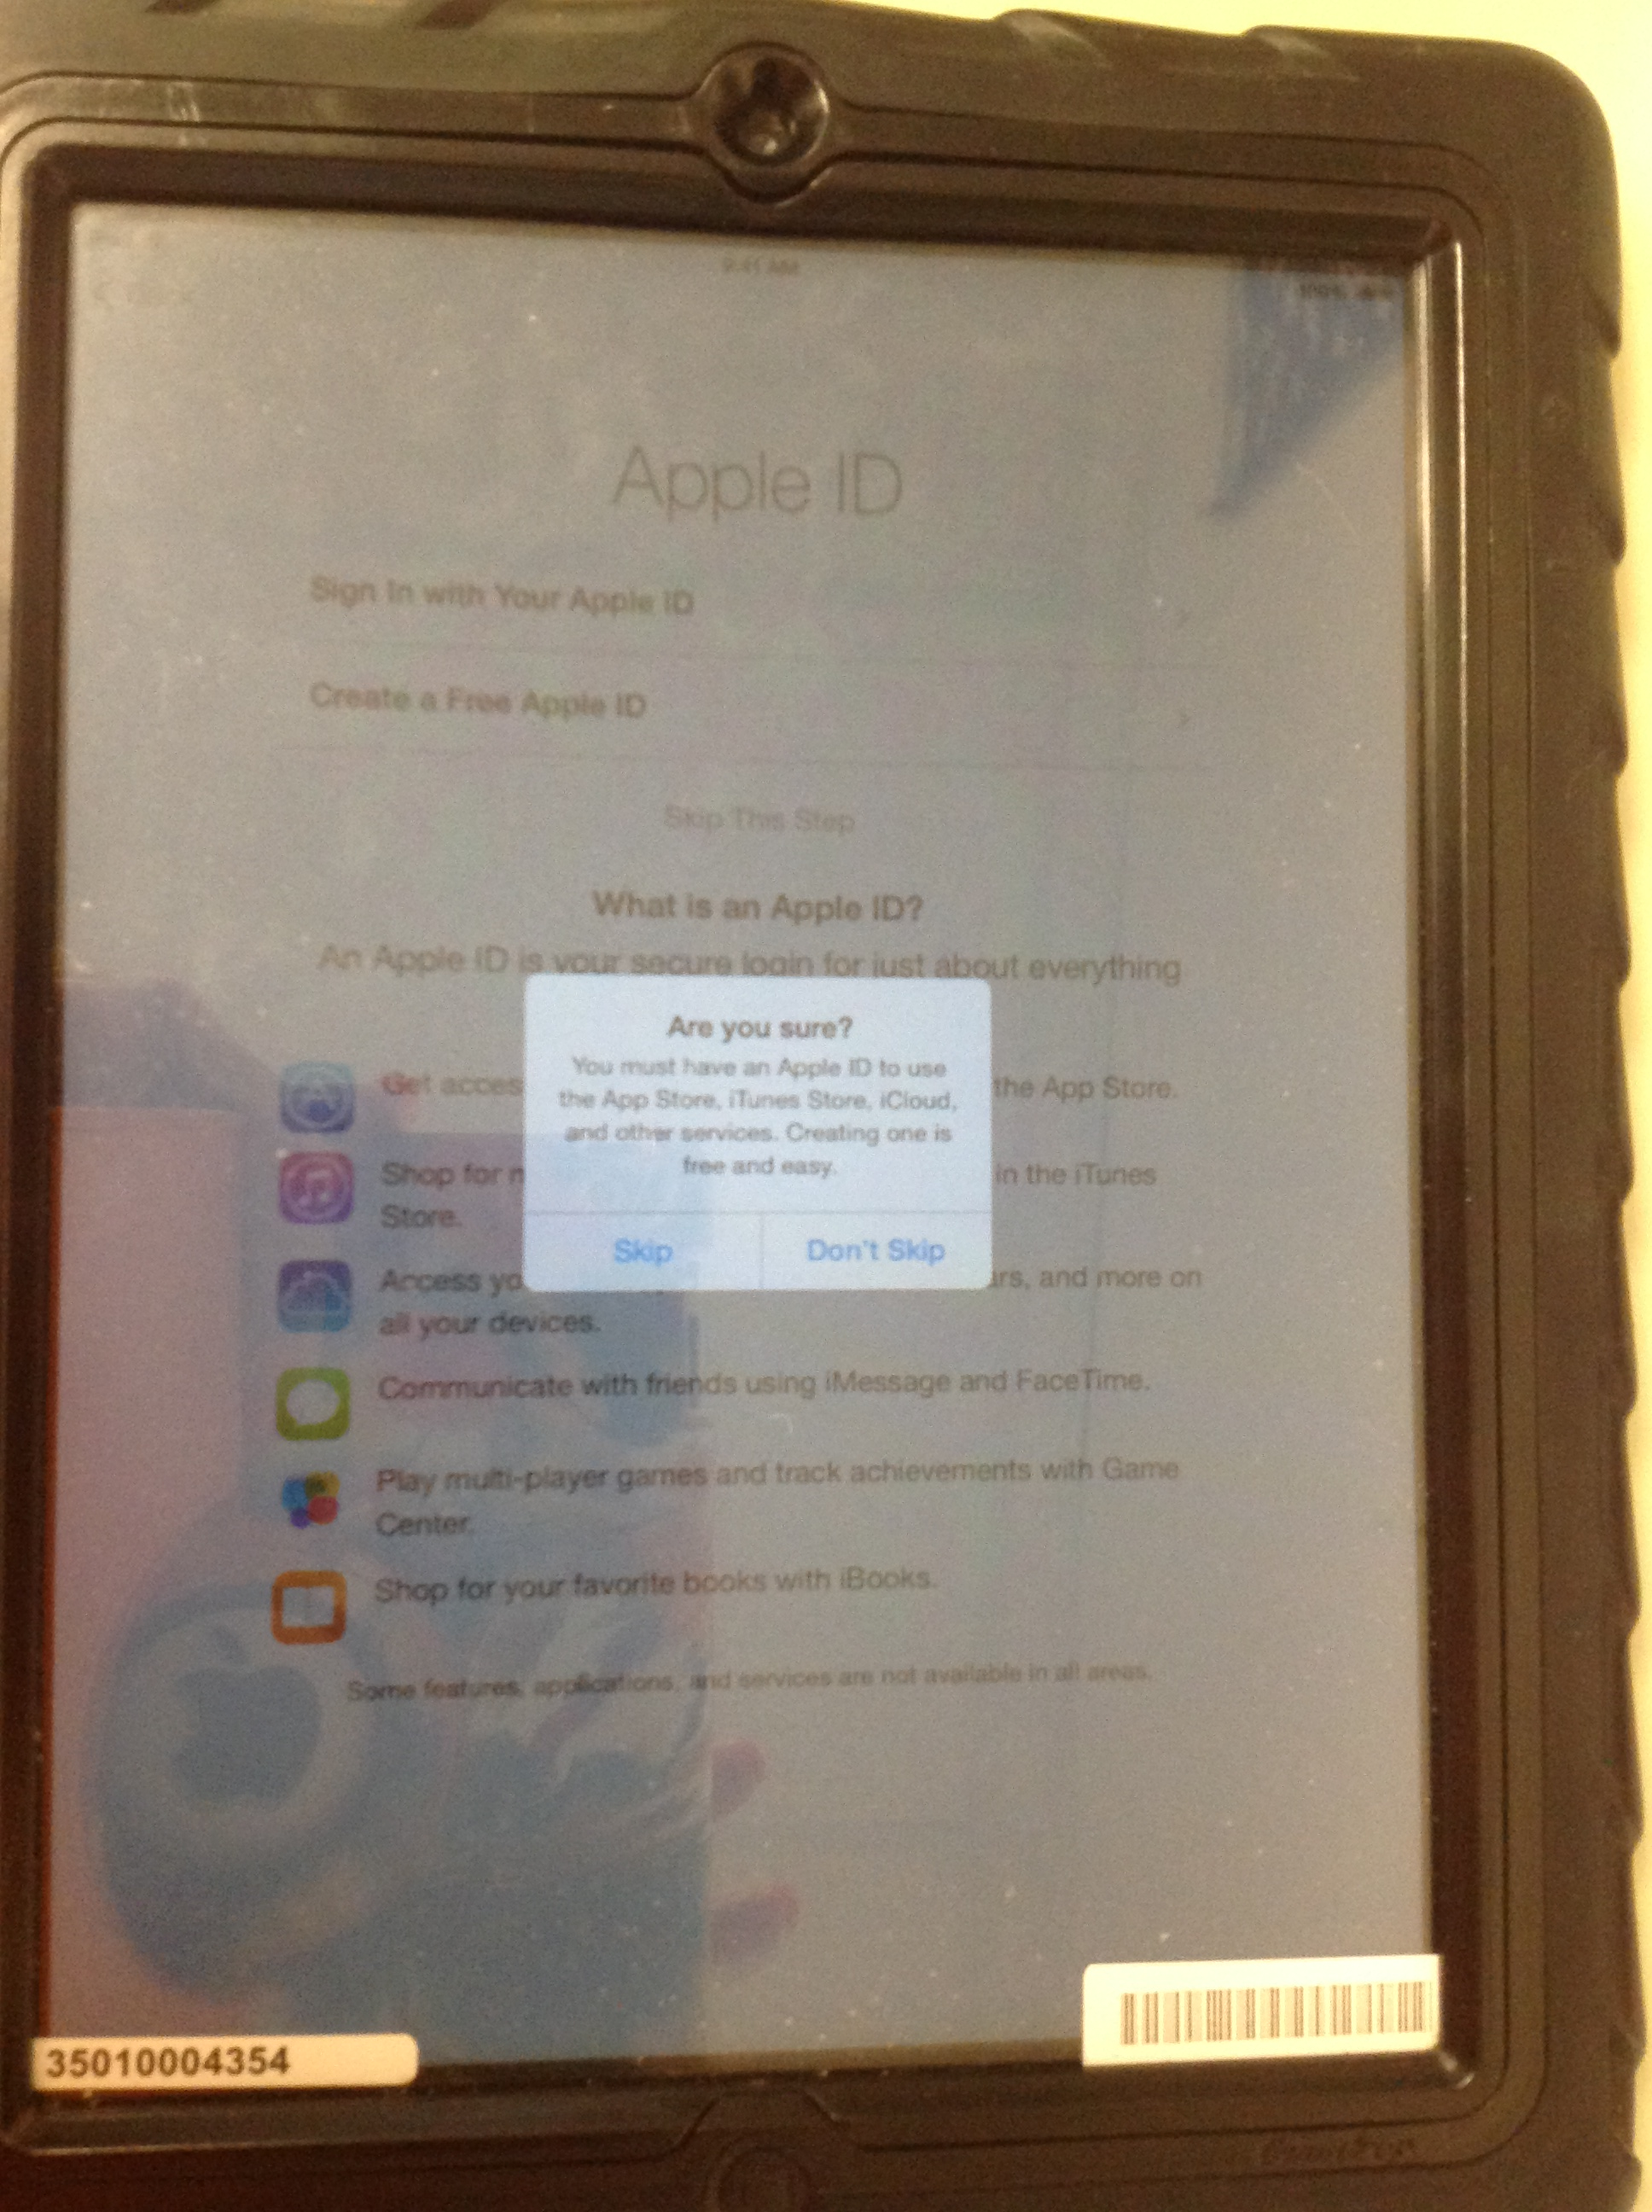

Next you will be taken to a “Create a Passcode” page. DO NOT create a passcode. Tap on “Don’t add Passcode.”

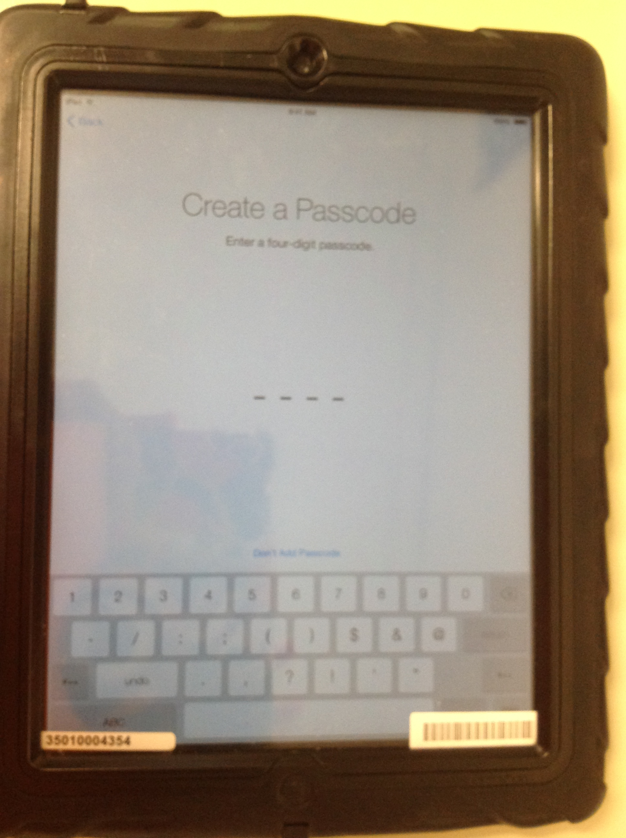

- A white box will pop up telling you that a passcode will secure your iPad. DO NOT add a passcode. Tap on “Continue.”

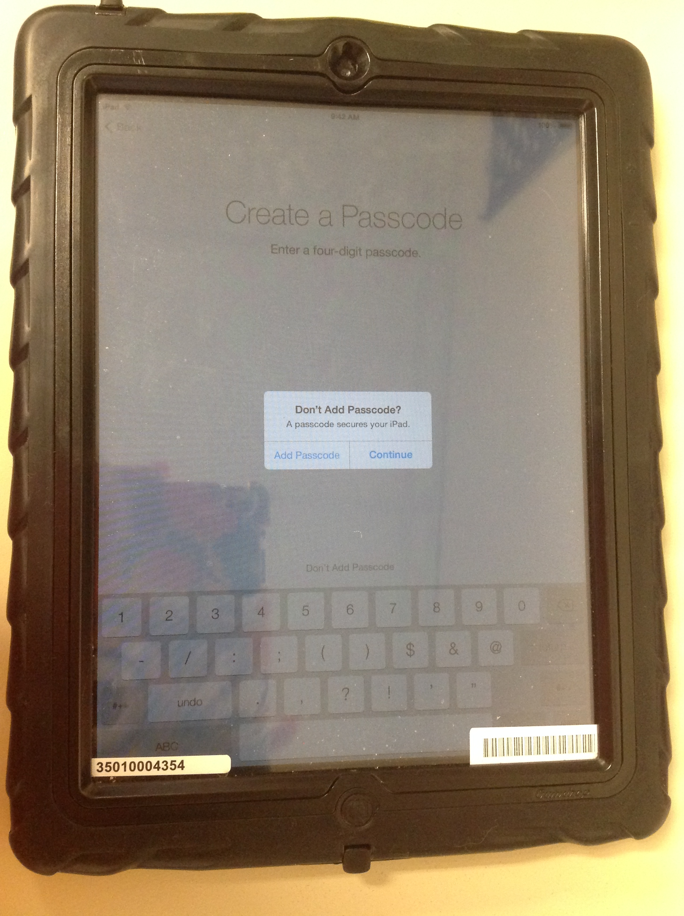

- Tap on “Get Started”

- Tap “Dismiss”

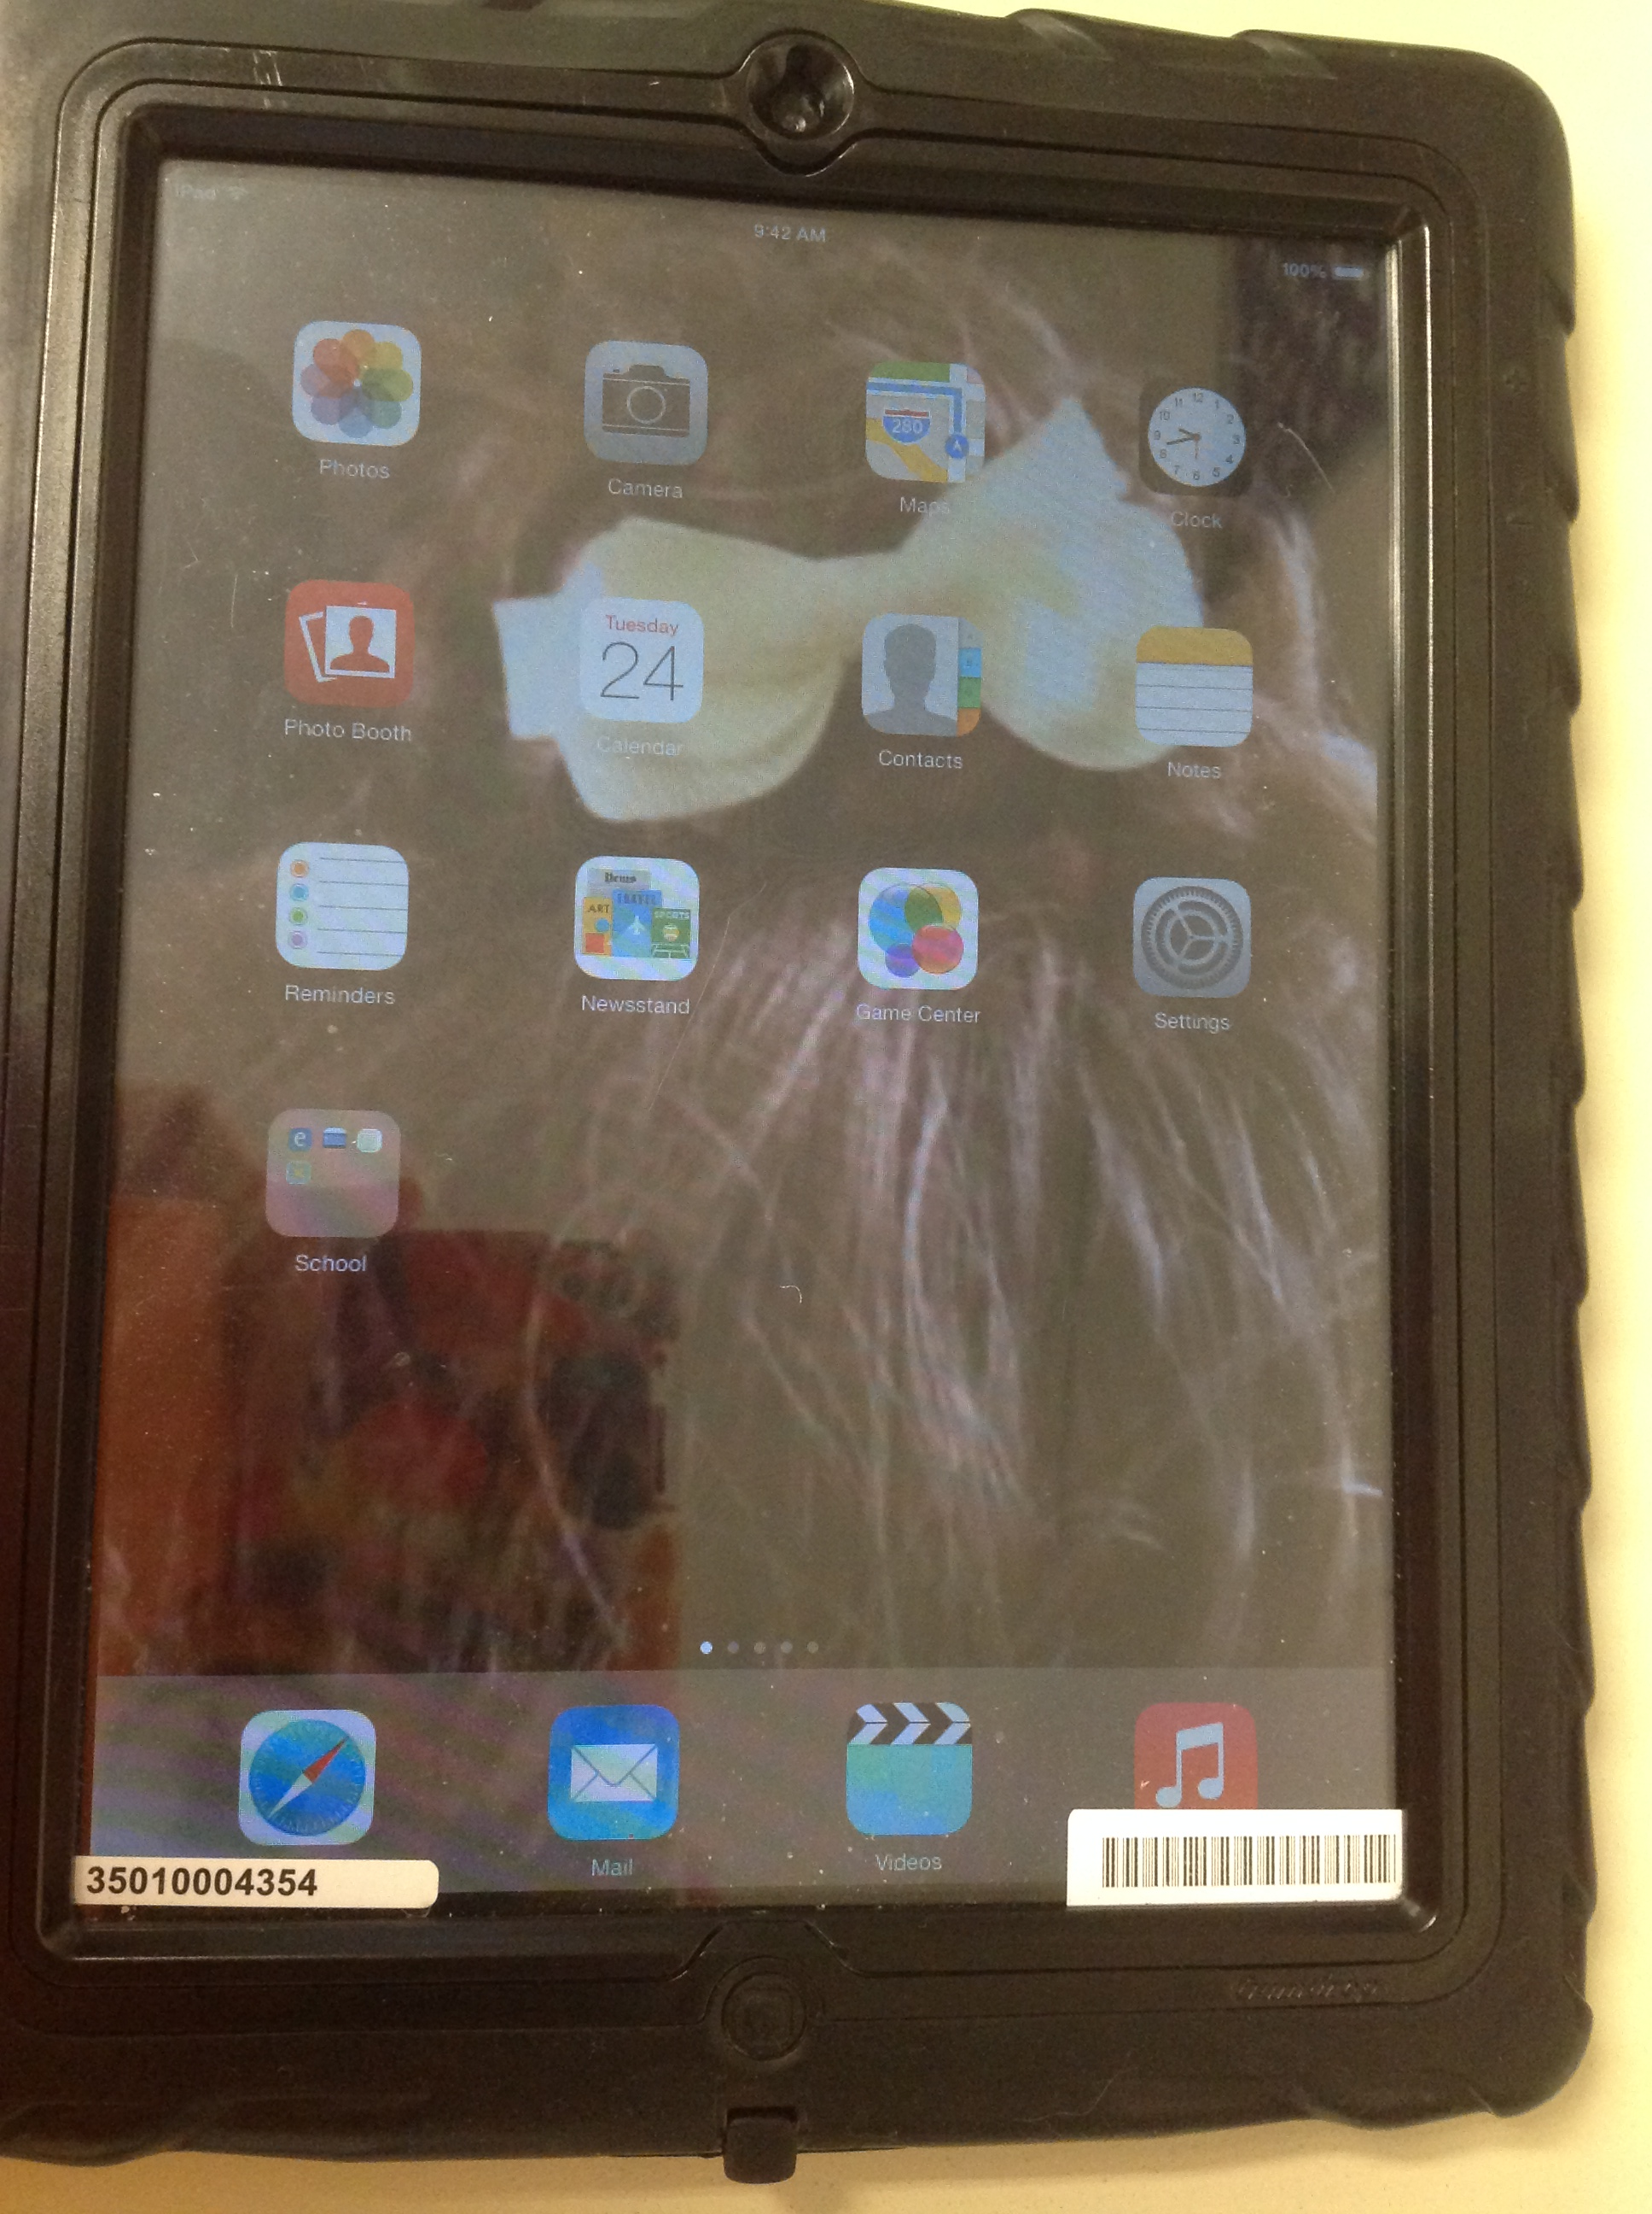

- Your iPad is now ready to use!

